UNITED STATES
SECURITIES AND EXCHANGE COMMISSION
WASHINGTON, D.C. 20549

FORM 6-K

REPORT OF FOREIGN PRIVATE ISSUER
PURSUANT TO RULE 13a-16 OR 15d-16 UNDER
THE SECURITIES EXCHANGE ACT OF 1934

For the month of May 2026
Commission File Number: 001-38328

LexinFintech Holdings Ltd.

27/F CES Tower
No. 3099 Keyuan South Road
Nanshan District, Shenzhen 518057
The People's Republic of China
(Address of principal executive offices)

Indicate by check mark whether the registrant files or will file annual reports under cover of Form 20-F or Form 40-F.
Form 20-F ___X____ Form 40-F _________

SIGNATURES
Pursuant to the requirements of the Securities Exchange Act of 1934, the registrant has duly caused this report to be signed on its behalf by the undersigned, thereunto duly authorized.

LexinFintech Holdings Ltd.
By |  | /s/ James Xigui Zheng
Name: |  | James Xigui Zheng
Title: |  | Chief Financial Officer

Date: May 25, 2026

Exhibit Index
Exhibit 99.1—Press Release

Exhibit 99.1
LexinFintech Holdings Ltd. Reports First Quarter 2026
Unaudited Financial Results
SHENZHEN, China, May 25, 2026 (GLOBE NEWSWIRE) -- LexinFintech Holdings Ltd. (“Lexin” or the “Company”) (NASDAQ: LX), a leading technology-empowered personal financial service enabler in China, today announced its unaudited financial results for the quarter ended March 31, 2026.
Mr. Jay Wenjie Xiao, Chairman and Chief Executive Officer of Lexin, commented, "In the first quarter, despite the complex macroeconomic and industry environment, the diversified business ecosystem we have established demonstrated solid operational resilience. Total loan originations reached RMB57.9 billion, representing an increase of 15.9% quarter-over-quarter. This momentum was primarily driven by our non-Consumer Finance business—including Installment E-commerce, Offline Inclusive Financing, and Fintech-empowerment services—which accounted for nearly 50% of our total loan origination.
During the period, net income remained relatively steady quarter-over-quarter at RMB201 million. This bottom-line performance underscores the fundamental strength and diversity of our core business model. Underpinning these results, we achieved consistent improvements in asset quality by refining our risk management strategies and optimizing our product matrix.
We also continued to step up our investments in consumer rights protection and customer experience enhancements. Looking ahead, we remain fully committed to compliant operations. Leveraging our business ecosystem, we will continuously enhance our operational resilience to navigate evolving market dynamics, achieve sustainable growth, and deliver long-term returns for our shareholders."
Mr. James Zheng, Chief Financial Officer of Lexin, commented, "Building on the resilience of our business ecosystem, we have proactively optimized our business mix this quarter to focus on high-quality growth. While the strategic shift in our consumer finance business and the broader macro environment moderated our current growth, our expanding business ecosystem provided a structural buffer. In the first quarter, our total revenue was RMB3.3 billion, representing an 8.7% increase quarter-over-quarter.
With a focus on long-term sustainability, we increased our investments in ecosystem user engagement and upgraded our customer service infrastructure. We also further bolstered our financial foundation with ample provisioning. As a result, our net income stood at RMB201 million, remaining relatively stable quarter-over-quarter.
Looking ahead, while staying vigilant regarding persistent macro uncertainties, we will advance our diversified business ecosystem to ensure steady progress across market cycles and continue to deliver value to our shareholders."

First Quarter Operational Highlights:
User Base
•
Total number of registered users across our platform reached 250 million as of March 31, 2026, representing an increase of 7.6% from 232 million as of March 31, 2025.
•
Number of active users1 in the first quarter of 2026 was 5.2 million, representing an increase of 8.6% from 4.8 million in the first quarter of 2025.
•
Number of cumulative borrowers with successful drawdown was 38.2 million as of March 31, 2026, an increase of 10.8% from 34.5 million as of March 31, 2025.
Loan Facilitation Business
Page 1 of 13

•
As of March 31, 2026, we cumulatively originated RMB1,588 billion in loans, an increase of 15.4% from RMB1,377 billion as of March 31, 2025.
•
Total loan originations2 in the first quarter of 2026 was RMB57.9 billion, an increase of 12.2% from RMB51.6 billion in the first quarter of 2025.
•
Total outstanding principal balance of loans3 was RMB96.5 billion as of March 31, 2026, representing a decrease of 10.1% from RMB107 billion as of March 31, 2025.
Credit Performance4
•
90 day+ delinquency ratio5 was 3.5% as of March 31, 2026, as compared with 3.1% as of December 31, 2025.
•
First payment default rate (30 day+) for new loan originations was below 1% as of March 31, 2026.
Installment E-commerce Platform Service
•
GMV6 in the first quarter of 2026 for our installment e-commerce platform service was RMB2,198 million, representing an increase of 95% from RMB1,126 million in the first quarter of 2025.
•
In the first quarter of 2026, our installment e-commerce platform service served over 600,000 users.
Other Operational Highlights
•
The weighted average tenor of loans originated in the first quarter of 2026 was approximately 11.4 months, as compared with 13.4 months in the first quarter of 2025.
•
Repeated borrowers’ contribution7 of loans across our platform for the first quarter of 2026 was 89.9%.
First Quarter 2026 Financial Highlights:
•
Total operating revenue was RMB3,309 million, representing an increase of 6.6% from the first quarter of 2025.
•
Credit facilitation service income was RMB2,232 million, representing an increase of 1.9% from the first quarter of 2025. Tech-empowerment service income was RMB553 million, representing a decrease of 11.5% from the first quarter of 2025. Installment e-commerce platform service income was RMB525 million, representing an increase of 81.9% from the first quarter of 2025.
•
Net income attributable to ordinary shareholders of the Company was RMB201 million, representing a decrease of 53.2% from the first quarter of 2025. Net income per ADS attributable to ordinary shareholders of the Company was RMB1.20 on a fully diluted basis.
•
Adjusted net income attributable to ordinary shareholders of the Company8 was RMB228 million, representing a decrease of 51.6% from the first quarter of 2025. Adjusted net income per ADS attributable to ordinary shareholders of the Company8 was RMB1.35 on a fully diluted basis.
__________________________
1.
Active users refer to, for a specified period, users who made at least one transaction during that period through our platform or through our third-party partners’ platforms using the credit line granted by us.
2.
Total loan originations refer to the total principal amount of loans originated during the given period through our platform or through our third-party partners' platforms.
3.
Total outstanding principal balance of loans refers to the total amount of principal outstanding for loans facilitated and originated at the end of each period, including loans guaranteed by our financial guarantee companies and the loans facilitated across third party platforms that we bear principal risk and excluding loans delinquent for more than 180 days that are charged-off.
4.
Loans under Intelligent Credit Platform are excluded from the calculation of credit performance. Intelligent Credit Platform (ICP) is an intelligent platform on our “Fenqile” app, under which we match borrowers and financial institutions through big data and cloud computing technology. For loans facilitated through ICP, the Company does not bear principal risk.
5.
“90 day+ delinquency rate” refers to the outstanding principal balance of on- and off-balance sheet loans that were 91 to 180 calendar days past due as a percentage of the total outstanding principal balance of on- and off-balance sheet loans across our platform and those loans across third
Page 2 of 13

party platforms that we bear principle risk as of a specific date. Loans that are charged-off and loans under “ICP”, E-commerce business and overseas are not included in the delinquency rate calculation.
6.
GMV refers to the total value of transactions completed for products purchased on our e-commerce and Maiya channel, net of returns.
7.
Repeated borrowers’ contribution for a given period refers to the principal amount of loans borrowed during that period by borrowers who had previously made at least one successful drawdown as a percentage of the total loan facilitation and origination volume through our platform during that period.
8.
Adjusted net income attributable to ordinary shareholders of the Company, adjusted net income per ordinary share and per ADS attributable to ordinary shareholders of the Company are non-GAAP financial measures. For more information on non-GAAP financial measures, please see the section of “Use of Non-GAAP Financial Measures Statement” and the tables captioned “Unaudited Reconciliations of GAAP and Non-GAAP Results” set forth at the end of this press release.
First Quarter 2026 Financial Results:
Operating revenue was RMB3,309 million in the first quarter of 2026, as compared to RMB3,104 million in the first quarter of 2025.
Credit facilitation service income was RMB2,232 million in the first quarter of 2026, as compared to RMB2,191 million in the first quarter of 2025. The increase was due to the increase in guarantee income.
Loan facilitation and servicing fees-credit oriented was RMB1,038 million in the first quarter of 2026, as compared to RMB1,136 million in the first quarter of 2025. The decrease was primarily due to the decrease in the APR of off-balance sheet loans and the decrease in origination of off-balance sheet loans.

Guarantee income was RMB727 million in the first quarter of 2026, as compared to RMB548 million in the first quarter of 2025. The increase was primarily due to the increase of outstanding balances in the off-balance sheet loans funded by certain institutional funding partners, which are accounted for under ASC 460, Guarantees.

Financing income was RMB467 million in the first quarter of 2026, as compared to RMB507 million in the first quarter of 2025.

Tech-empowerment service income was RMB553 million in the first quarter of 2026, as compared to RMB625 million in the first quarter of 2025. The decrease was primarily due to the decrease of loan facilitation volume through ICP.

Installment e-commerce platform service income was RMB525 million in the first quarter of 2026, as compared to RMB288 million in the first quarter of 2025. The increase was primarily driven by the increase in transaction volume with third-party sellers.
Cost of sales consisted of cost of inventory sold and other costs. Cost of sales was RMB349 million in the first quarter of 2026, as compared to RMB262 million in the first quarter of 2025. The increase was primarily driven by the increase in transaction volume of online direct sales which is recorded on a gross basis.
Funding cost was RMB55.6 million in the first quarter of 2026, as compared to RMB83.0 million in the first quarter of 2025. The decrease was primarily driven by the decrease in funding rates and balance of funding debts to fund the on-balance sheet loans.
Processing and servicing costs was RMB634 million in the first quarter of 2026, as compared to RMB551 million in the first quarter of 2025.The increase was primarily due to the increase in risk management expenses.
Provision for financing receivables was RMB341 million in the first quarter of 2026, as compared to RMB182 million in the first quarter of 2025. The increase was primarily due to the changes in loan portfolio of on balance sheet loans.
Provision for contract assets and receivables was RMB137 million in the first quarter of 2026, as compared to RMB130 million in the first quarter of 2025.
Page 3 of 13

Provision for contingent guarantee liabilities was RMB959 million in the first quarter of 2026, as compared to RMB677 million in the first quarter of 2025. The increase was primarily due to the increase of outstanding balances in the off-balance sheet loans funded by certain institutional funding partners, which are accounted for under ASC 460, Guarantees.
Gross profit was RMB835 million in the first quarter of 2026, as compared to RMB1,219 million in the first quarter of 2025.
Sales and marketing expenses was RMB512 million in the first quarter of 2026, as compared to RMB493 million in the first quarter of 2025. The increase was primarily driven by the increase in personnel-related costs.
Research and development expenses was RMB148 million in the first quarter of 2026, as compared to RMB156 million in the first quarter of 2025.
General and administrative expenses was RMB97.5 million in the first quarter of 2026, as compared to RMB101 million in the first quarter of 2025.
Change in fair value of financial guarantee derivatives and loans at fair value was a gain of RMB161 million in the first quarter of 2026, as compared to a gain of RMB74.6 million in the first quarter of 2025. The change was primarily driven by the fair value gains realized as a result of the release of guarantee obligation as loans are repaid, partially offset by the fair value loss from the re-measurement of the expected loss rates.
Income tax expense was RMB68.0 million in the first quarter of 2026, as compared to RMB101 million in the first quarter of 2025. The decrease was primarily due to the decrease in income before income tax expense.
Net income was RMB201 million in the first quarter of 2026, as compared to RMB430 million in the first quarter of 2025.

Page 4 of 13

Recent Development

Update of Share Repurchase Program
Pursuant to the share repurchase program of up to US$50 million adopted in July 2025, the Company repurchased a total of approximately 9.6 million ADSs (equivalent to 19.2 million Class A ordinary shares) for approximately US$39 million. The remaining amount under the share repurchase program was US$11 million as of the date of this announcement. The total number of shares repurchased by the Company since the adoption of the share repurchase program amounted to approximately 5.9% of its total ordinary shares outstanding as of March 31, 2026.

Business Outlook
Looking ahead, while our risk metrics continue to improve, we remain prudent in light of ongoing macroeconomic uncertainties and expect total loan origination for the second quarter of 2026 to remain relatively flat.
This forecast reflects our current preliminary views, which are subject to the impact of macroeconomic factors. The Company may adjust its performance outlook as appropriate based on evolving circumstances.
Conference Call
The Company’s management will host an earnings conference call at 7:00 AM U.S. Eastern time on May 25, 2026 (7:00 PM Beijing/Hong Kong time on May 25, 2026).
Participants who wish to join the conference call should register online at:
https://register-conf.media-server.com/register/BIdbf6538c90c542929a234504dca02fbc
Once registration is completed, each participant will receive the dial-in number and a unique access PIN for the conference call.
Participants joining the conference call should dial in at least 10 minutes before the scheduled start time.
A live and archived webcast of the conference call will also be available at the Company's investor relations website at http://ir.lexin.com.
About LexinFintech Holdings Ltd.
We are a leading credit technology-empowered personal financial service enabler. Our mission is to use technology and risk management expertise to make financing more accessible for young generation consumers. We strive to achieve this mission by connecting consumers with financial institutions, where we facilitate through a unique model that includes online and offline channels, installment consumption platform, big data and AI driven credit risk management capabilities, as well as smart user and loan management systems. We also empower financial institutions by providing cutting-edge proprietary technology solutions to meet their needs of financial digital transformation.
For more information, please visit http://ir.lexin.com.
To follow us on Twitter, please go to: https://twitter.com/LexinFintech.
Page 5 of 13

Use of Non-GAAP Financial Measures Statement
In evaluating our business, we consider and use adjusted net income attributable to ordinary shareholders of the Company, non-GAAP EBIT, adjusted net income per ordinary share and per ADS attributable to ordinary shareholders of the Company, four non-GAAP measures, as supplemental measures to review and assess our operating performance. The presentation of the non-GAAP financial measures is not intended to be considered in isolation or as a substitute for the financial information prepared and presented in accordance with U.S. GAAP. We define adjusted net income attributable to ordinary shareholders of the Company as net income attributable to ordinary shareholders of the Company excluding share-based compensation expenses, interest expense associated with convertible notes, and investment income/(loss) and we define non-GAAP EBIT as net income excluding income tax expense, share-based compensation expenses, interest expense, net, and investment income/(loss).
We present these non-GAAP financial measures because they are used by our management to evaluate our operating performance and formulate business plans. Adjusted net income attributable to ordinary shareholders of the Company enables our management to assess our operating results without considering the impact of share-based compensation expenses, interest expense associated with convertible notes, and investment income/(loss). Non-GAAP EBIT, on the other hand, enables our management to assess our operating results without considering the impact of income tax expense, share-based compensation expenses, interest expense, net, and investment income/(loss). We also believe that the use of these non-GAAP financial measures facilitates investors’ assessment of our operating performance. These non-GAAP financial measures are not defined under U.S. GAAP and are not presented in accordance with U.S. GAAP.
These non-GAAP financial measures have limitations as an analytical tool. One of the key limitations of using adjusted net income attributable to ordinary shareholders of the Company and non-GAAP EBIT is that they do not reflect all items of income and expense that affect our operations. Share-based compensation expenses, interest expense associated with convertible notes, income tax expense, interest expense, net, and investment income/(loss) have been and may continue to be incurred in our business and are not reflected in the presentation of adjusted net income attributable to ordinary shareholders of the Company and non-GAAP EBIT. Further, these non-GAAP financial measures may differ from the non-GAAP financial information used by other companies, including peer companies, and therefore their comparability may be limited.
We compensate for these limitations by reconciling each of the non-GAAP financial measures to the most directly comparable U.S. GAAP financial measure, which should be considered when evaluating our performance. We encourage you to review our financial information in its entirety and not rely on a single financial measure.
Exchange Rate Information Statement
This announcement contains translations of certain RMB amounts into U.S. dollars (“US$”) at specified rates solely for the convenience of the reader. Unless otherwise stated, all translations from RMB to US$ were made at the rate of RMB6.8980 to US$1.00, the exchange rate set forth in the H.10 statistical release of the Federal Reserve Board on March 31, 2026. The Company makes no representation that the RMB or US$ amounts referred could be converted into US$ or RMB, as the case may be, at any particular rate or at all.
Page 6 of 13

Safe Harbor Statement
This announcement contains forward-looking statements. These statements are made under the “safe harbor” provisions of the U.S. Private Securities Litigation Reform Act of 1995. Statements that are not historical facts, including statements about Lexin’s beliefs and expectations, are forward-looking statements. These forward-looking statements can be identified by terminology such as “will,” “expects,” “anticipates,” “future,” “intends,” “plans,” “believes,” “estimates,” “confident” and similar statements. Among other things, the expectation of the collection efficiency and delinquency, business outlook and quotations from management in this announcement, contain forward-looking statements. Lexin may also make written or oral forward-looking statements in its periodic reports to the U.S. Securities and Exchange Commission (the “SEC”), in its annual report to shareholders, in press releases and other written materials and in oral statements made by its officers, directors or employees to third parties. Forward-looking statements involve inherent risks and uncertainties. A number of factors could cause actual results to differ materially from those contained in any forward-looking statement, including but not limited to the following: Lexin’s goal and strategies; Lexin’s expansion plans; Lexin’s future business development, financial condition and results of operations; Lexin’s expectation regarding demand for, and market acceptance of, its credit and investment management products; Lexin’s expectations regarding keeping and strengthening its relationship with borrowers, institutional funding partners, merchandise suppliers and other parties it collaborates with; general economic and business conditions; and assumptions underlying or related to any of the foregoing. Further information regarding these and other risks is included in Lexin’s filings with the SEC. All information provided in this press release and in the attachments is as of the date of this press release, and Lexin does not undertake any obligation to update any forward-looking statement, except as required under applicable law.
For investor and media inquiries, please contact:
LexinFintech Holdings Ltd.
IR inquiries:
Will Tan
Tel: +86 (755) 3637-8888 ext. 6258
E-mail: willtan@lexin.com

Media inquiries:
Ruifeng Xu
Tel: +86 (755) 3637-8888 ext. 6993
E-mail: media@lexin.com
SOURCE LexinFintech Holdings Ltd.
Page 7 of 13

LexinFintech Holdings Ltd.
Unaudited Condensed Consolidated Balance Sheets
 | As of
(In thousands) | December 31, 2025 |  |  | March 31, 2026
 | RMB |  |  | RMB |  |  | US$
ASSETS
Current Assets
Cash and cash equivalents |  | 2,156,133 |  |  | 1,578,364 |  |  | 228,815
Restricted cash |  | 1,717,773 |  |  | 1,546,223 |  |  | 224,155
Restricted term deposit and short-term investments |  | 78,458 |  |  | 111,552 |  |  | 16,172
Short-term financing receivables, net(1) |  | 5,450,418 |  |  | 4,995,983 |  |  | 724,265
Short-term contract assets and receivables, net(1) |  | 3,763,096 |  |  | 3,832,452 |  |  | 555,589
Deposits to insurance companies and guarantee companies |  | 2,187,609 |  |  | 2,231,062 |  |  | 323,436
Prepayments and other current assets |  | 2,858,054 |  |  | 3,416,870 |  |  | 495,342
Amounts due from related parties |  | 84,531 |  |  | 116,874 |  |  | 16,943
Inventories, net |  | 24,119 |  |  | 20,932 |  |  | 3,035
Total Current Assets |  | 18,320,191 |  |  | 17,850,312 |  |  | 2,587,752
Non-current Assets
Restricted cash |  | 91,937 |  |  | 71,082 |  |  | 10,305
Long-term financing receivables, net(1) |  | 167,378 |  |  | 162,213 |  |  | 23,516
Long-term contract assets and receivables, net(1) |  | 317,496 |  |  | 317,580 |  |  | 46,039
Property, equipment and software, net |  | 895,046 |  |  | 959,103 |  |  | 139,041
Land use rights, net |  | 828,467 |  |  | 819,867 |  |  | 118,856
Long-term investments |  | 243,971 |  |  | 243,960 |  |  | 35,367
Deferred tax assets |  | 1,763,235 |  |  | 1,848,738 |  |  | 268,011
Other assets |  | 535,242 |  |  | 493,903 |  |  | 71,601
Total Non-current Assets |  | 4,842,772 |  |  | 4,916,446 |  |  | 712,736
TOTAL ASSETS |  | 23,162,963 |  |  | 22,766,758 |  |  | 3,300,488
LIABILITIES
Current liabilities
Accounts payable |  | 101,178 |  |  | 113,260 |  |  | 16,419
Amounts due to related parties |  | 8,708 |  |  | 8,334 |  |  | 1,208
Short-term borrowings and current portion of long-term borrowings |  | 905,791 |  |  | 864,977 |  |  | 125,395
Short-term funding debts |  | 2,440,685 |  |  | 1,418,034 |  |  | 205,572
Deferred guarantee income |  | 1,305,911 |  |  | 1,372,030 |  |  | 198,903
Contingent guarantee liabilities |  | 544,191 |  |  | 381,635 |  |  | 55,325
Accruals and other current liabilities |  | 4,371,484 |  |  | 4,652,999 |  |  | 674,541
Total Current Liabilities |  | 9,677,948 |  |  | 8,811,269 |  |  | 1,277,363
Non-current Liabilities
Long-term borrowings |  | 566,015 |  |  | 620,145 |  |  | 89,902
Long-term funding debts |  | 850,590 |  |  | 1,144,023 |  |  | 165,849
Deferred tax liabilities |  | 105,212 |  |  | 78,450 |  |  | 11,373
Other long-term liabilities |  | 10,567 |  |  | 8,421 |  |  | 1,221
Total Non-current Liabilities |  | 1,532,384 |  |  | 1,851,039 |  |  | 268,345
TOTAL LIABILITIES |  | 11,210,332 |  |  | 10,662,308 |  |  | 1,545,708
Shareholders’ equity:
Class A Ordinary Shares |  | 209 |  |  | 210 |  |  | 32
Class B Ordinary Shares |  | 41 |  |  | 41 |  |  | 7
Treasury stock |  | (493,846 | ) |  | (570,140 | ) |  | (82,653 | )
Additional paid-in capital |  | 3,396,667 |  |  | 3,420,377 |  |  | 495,851
Statutory reserves |  | 1,260,923 |  |  | 1,260,923 |  |  | 182,795
Accumulated other comprehensive income |  | (27,597 | ) |  | (24,635 | ) |  | (3,571 | )
Retained earnings |  | 7,816,234 |  |  | 8,017,674 |  |  | 1,162,319
Total shareholders’ equity |  | 11,952,631 |  |  | 12,104,450 |  |  | 1,754,780
TOTAL LIABILITIES AND SHAREHOLDERS’ EQUITY |  | 23,162,963 |  |  | 22,766,758 |  |  | 3,300,488
__________________________
(1) Short-term financing receivables, net of allowance for credit losses of RMB198,694 and RMB208,703 as of December 31, 2025 and March 31, 2026, respectively.
Short-term contract assets and receivables, net of allowance for credit losses of RMB259,054 and RMB303,608 as of December 31, 2025 and March 31, 2026, respectively.
Long-term financing receivables, net of allowance for credit losses of RMB3,723 and RMB3,336 as of December 31, 2025 and March 31, 2026, respectively.
Long-term contract assets and receivables, net of allowance for credit losses of RMB14,569 and RMB11,356 as of December 31, 2025 and March 31, 2026, respectively.
Page 8 of 13

LexinFintech Holdings Ltd.
Unaudited Condensed Consolidated Statements of Operations
 | For the Three Months Ended March 31,
(In thousands, except for share and per share data) | 2025 |  |  | 2026
 | RMB |  |  | RMB |  |  | US$
Operating revenue:
Credit facilitation service income |  | 2,190,866 |  |  | 2,231,671 |  |  | 323,524
Loan facilitation and servicing fees-credit oriented |  | 1,136,229 |  |  | 1,037,929 |  |  | 150,468
Guarantee income |  | 547,814 |  |  | 727,076 |  |  | 105,404
Financing income |  | 506,823 |  |  | 466,666 |  |  | 67,652
Tech-empowerment service income |  | 624,850 |  |  | 552,800 |  |  | 80,139
Installment e-commerce platform service income |  | 288,383 |  |  | 524,667 |  |  | 76,061
Total operating revenue |  | 3,104,099 |  |  | 3,309,138 |  |  | 479,724
Operating cost
Cost of sales |  | (262,032 | ) |  | (348,699 | ) |  | (50,551 | )
Funding cost |  | (83,004 | ) |  | (55,642 | ) |  | (8,066 | )
Processing and servicing cost |  | (551,141 | ) |  | (633,850 | ) |  | (91,889 | )
Provision for financing receivables |  | (182,149 | ) |  | (340,660 | ) |  | (49,385 | )
Provision for contract assets and receivables |  | (129,685 | ) |  | (136,509 | ) |  | (19,790 | )
Provision for contingent guarantee liabilities |  | (677,180 | ) |  | (959,152 | ) |  | (139,048 | )
Total operating cost |  | (1,885,191 | ) |  | (2,474,512 | ) |  | (358,729 | )
Gross profit |  | 1,218,908 |  |  | 834,626 |  |  | 120,995
Operating expenses:
Sales and marketing expenses |  | (493,128 | ) |  | (511,956 | ) |  | (74,218 | )
Research and development expenses |  | (155,626 | ) |  | (148,292 | ) |  | (21,498 | )
General and administrative expenses |  | (100,753 | ) |  | (97,505 | ) |  | (14,135 | )
Total operating expenses |  | (749,507 | ) |  | (757,753 | ) |  | (109,851 | )
Change in fair value of financial guarantee derivatives and loans at fair value |  | 74,639 |  |  | 161,219 |  |  | 23,372
Interest expense, net |  | (4,702 | ) |  | (5,308 | ) |  | (769 | )
Investment loss |  | (11,699 | ) |  | (3,508 | ) |  | (509 | )
Others, net |  | 3,832 |  |  | 40,130 |  |  | 5,818
Income before income tax expense |  | 531,471 |  |  | 269,406 |  |  | 39,056
Income tax expense |  | (101,147 | ) |  | (67,966 | ) |  | (9,853 | )
Net income |  | 430,324 |  |  | 201,440 |  |  | 29,203
Net income attributable to ordinary shareholders of the Company |  | 430,324 |  |  | 201,440 |  |  | 29,203
Net income per ordinary share attributable to ordinary shareholders of the Company
Basic |  | 1.27 |  |  | 0.61 |  |  | 0.09
Diluted |  | 1.20 |  |  | 0.60 |  |  | 0.09
Net income per ADS attributable to ordinary shareholders of the Company
Basic |  | 2.55 |  |  | 1.21 |  |  | 0.18
Diluted |  | 2.39 |  |  | 1.20 |  |  | 0.17
Weighted average ordinary shares outstanding
Basic |  | 338,073,723 |  |  | 331,600,933 |  |  | 331,600,933
Diluted |  | 359,646,902 |  |  | 336,653,349 |  |  | 336,653,349

Page 9 of 13

LexinFintech Holdings Ltd.
Unaudited Condensed Consolidated Statements of Comprehensive Income

 | For the Three Months Ended March 31,
(In thousands) | 2025 |  |  | 2026
 | RMB |  |  | RMB |  |  | US$
Net income |  | 430,324 |  |  | 201,440 |  |  | 29,203
Other comprehensive income
Foreign currency translation adjustment, net of nil tax |  | (2,259 | ) |  | 2,962 |  |  | 429
Total comprehensive income |  | 428,065 |  |  | 204,402 |  |  | 29,632
Total comprehensive income attributable to ordinary shareholders of the Company |  | 428,065 |  |  | 204,402 |  |  | 29,632

Page 10 of 13

LexinFintech Holdings Ltd.
Unaudited Reconciliations of GAAP and Non-GAAP Results

 | For the Three Months Ended March 31,
(In thousands, except for share and per share data) | 2025 |  |  | 2026
 | RMB |  |  | RMB |  |  | US$
Reconciliation of Adjusted net income attributable to ordinary shareholders of the Company to Net income attributable to ordinary shareholders of the Company
Net income attributable to ordinary shareholders of the Company |  | 430,324 |  |  | 201,440 |  |  | 29,203
Add: Share-based compensation expenses |  | 29,541 |  |  | 23,106 |  |  | 3,350
Investment loss |  | 11,699 |  |  | 3,508 |  |  | 509
Adjusted net income attributable to ordinary shareholders of the Company |  | 471,564 |  |  | 228,054 |  |  | 33,062
Adjusted net income per ordinary share attributable to ordinary shareholders of the Company
Basic |  | 1.39 |  |  | 0.69 |  |  | 0.10
Diluted |  | 1.31 |  |  | 0.68 |  |  | 0.10
Adjusted net income per ADS attributable to ordinary shareholders of the Company
Basic |  | 2.79 |  |  | 1.38 |  |  | 0.20
Diluted |  | 2.62 |  |  | 1.35 |  |  | 0.20
Weighted average shares used in calculating net income per ordinary share for non-GAAP EPS
Basic |  | 338,073,723 |  |  | 331,600,933 |  |  | 331,600,933
Diluted |  | 359,646,902 |  |  | 336,653,349 |  |  | 336,653,349
Reconciliations of Non-GAAP EBIT to Net income
Net income |  | 430,324 |  |  | 201,440 |  |  | 29,203
Add: Income tax expense |  | 101,147 |  |  | 67,966 |  |  | 9,853
Share-based compensation expenses |  | 29,541 |  |  | 23,106 |  |  | 3,350
Interest expense, net |  | 4,702 |  |  | 5,308 |  |  | 769
Investment loss |  | 11,699 |  |  | 3,508 |  |  | 509
Non-GAAP EBIT |  | 577,413 |  |  | 301,328 |  |  | 43,684

Page 11 of 13

Additional Credit Information
Vintage Charge Off Curve1
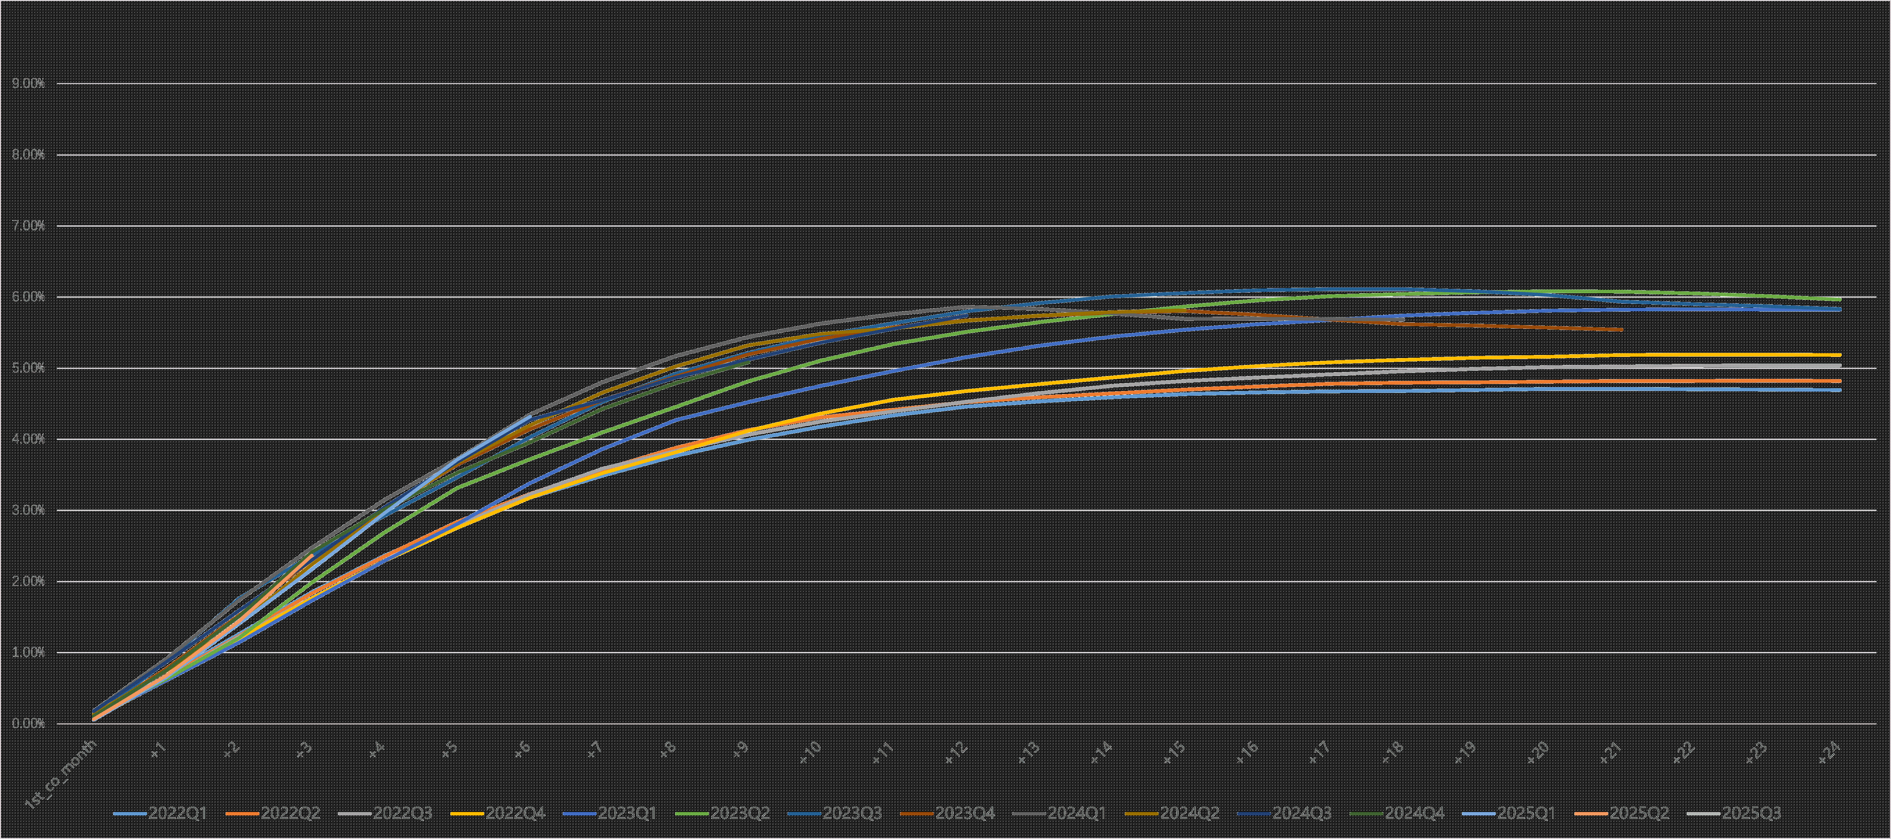

Dpd30+/GMV by Performance Windows1
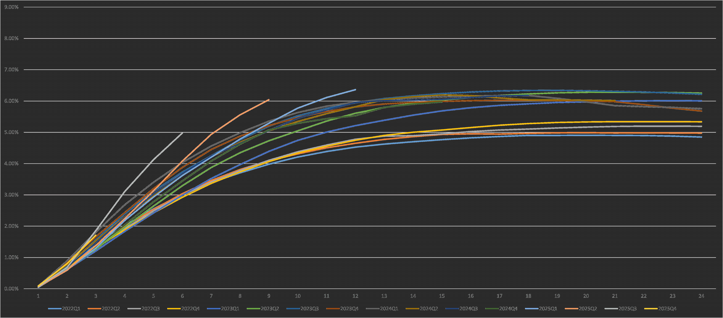

Page 12 of 13

First Payment Default 30+1

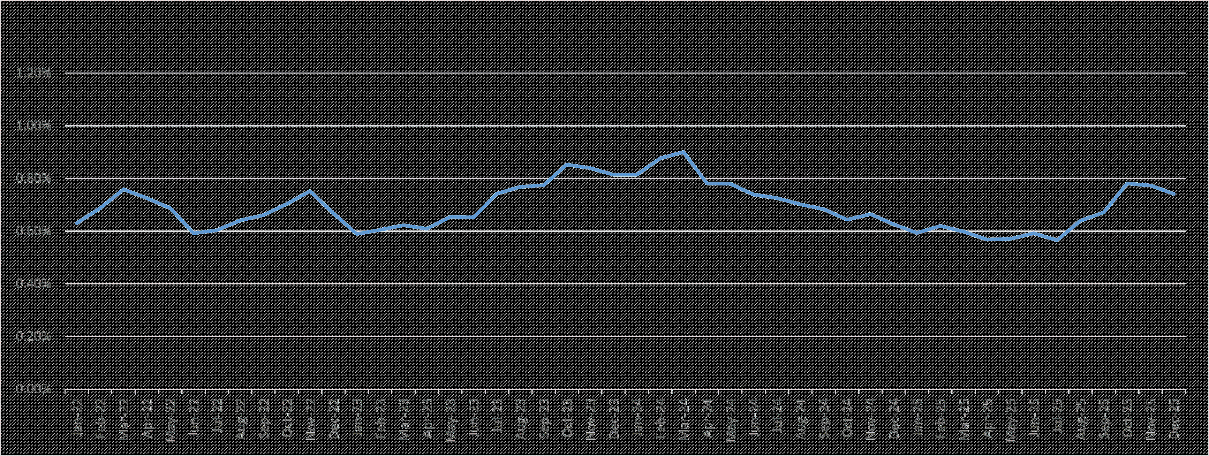1. Loans facilitated under ICP and E-commerce business are excluded from the charts.
Page 13 of 13

